Fit and Proper Person Assessment for Private Schools
Guidance for current private school managers

Introduction
Every current manager of a private school must be assessed as fit and proper for their school to meet, and continue to meet, one of the criteria for registration under the Education and Training Act 2020. School managers must be assessed as fit and proper every three years to provide ongoing assurance to the Director of Regulation that they are fit and proper persons.

Purpose
The purpose of this document is to provide private school managers with information on the private school fit and proper person assessment and step-by-step instructions on how to submit a fit and proper person application.

How to read this guidance
If you are a current manager of a private school, please read this guidance in its entirety.
The guidance has been divided into the following four sections:
Section 1: General information - private schools: Provides general information for private schools on the fit and proper person assessment.
Section 2: General information - managers of a private school: Provides general information for managers of private schools on making a fit and proper person application.
Section 3: Application checklist: Provides a checklist for managers of a private school to help them confirm they have everything they need to submit a fit and proper person application.
Section 4: Step-by-step instructions on submitting a fit and proper person application: Provides managers of a private school with step-by-step instructions (including screenshots) to support with submitting a fit and proper person application.
The content in Sections 2 - 4 is directed to managers of private schools and refers to ‘you’ (the private school manager) throughout. Section 4 is directed to each individual school manager, as applications must be submitted individually and not on behalf of someone else or a group.

Section 1: General information - private schools

Key points for private schools
- All managers of a private school must be assessed as fit and proper under this new digitised assessment, and then again every three years.
- If the management or governance structure of a private school changes, the private school must let ERO know. For information refer to the ERO website at www.ero.govt.nz for further information.
- A private school is responsible for ensuring that any newly appointed or employed school manager submits a fit and proper person application and is assessed as fit and proper.

Who are the ‘managers of a private school’?

Managers of a private school are defined in the Education and Training Act 2020 as all people who control and manage the school, whether or not they have a proprietary interest in it.

ERO’S advice is that you are deemed a school manager if you are at the level of Principal or above (e.g. Board members).

Every manager of a private school must be assessed as fit and proper. This means, for example, every Board member of a private school must be assessed as fit and proper.

If the manager of a private school is a company, each of the company’s directors must be assessed as fit and proper. Each of the company’s directors must individually submit their own fit and proper application.

If the manager of a private school is an incorporated society or an incorporated trust board, each of its members must be assessed as fit and proper. Each member must individually submit their own fit and proper application.

What is ‘fit and proper person’ and why is it assessed?
- When a private school manager is assessed as fit and proper, it means ERO has determined that they are suitable to be managers of a private school.
- The assessment is to support appropriate safeguarding of students and to maintain the integrity of the education system. It provides assurances to the Director of Regulation that a private school is being managed by people appropriate to do so.
- Under the Education and Training Act 2020, Schedule 7, Private Schools, Clause 6, Managers to be fit and proper persons, are a list of matters to be considered in assessing whether a manager of a private school is fit and proper. These matters include, for example, whether a school manager has been convicted of serious criminal activity or whether they have previously been bankrupt.
- Managers of a private school being assessed as fit and proper is one of a set of criteria private schools are required to satisfy in order to meet registration requirements.

Section 2: General information - managers of a private school

When am I required to submit a fit and proper application?
If you are a manager of a private school, you must submit an application and be assessed as fit and proper. You are required to be reassessed as fit and proper every three years. You are also required to submit an application when your situation changes (e.g. you become a manager of a different private school).
The following list sets out all scenarios where you must submit a fit and proper person application:
- As part of the initial registration process for new private schools applying to be registered as a private school
- As an existing school manager applying to be assessed for the first time (under this updated digitised fit and proper person assessment)
- When first appointed or employed in a school manager role
- If appointed or employed as a school manager of a new school, regardless of whether you have been assessed as fit and proper in relation to a previous private school.
- Before an existing fit and proper person assessment expires (three years after the date it was approved)
- If there has been a change in your situation, that may mean what you declared on your statutory declaration (submitted as part of your application) is no longer correct or is likely to impact the status of your fit and proper person assessment. This means any situation that may change what was declared on your statutory declaration.

How do I submit a fit and proper person application?
Submitting an application for current private school managers using an Education Sector Logon (ESL)
You need to submit your application online using an ESL. You can request access to create an ESL account from the delegated authoriser (DA) for ESL in your school. If you already have an ESL account, you can ask your DA for access to the fit and proper person education sector application. If you don’t know who your DA is, please refer to the information here.
Anyone who requires access to the fit and proper person application portal can request access to ESL.
Every manager of a private school must submit their own fit and proper person application. This means every school manager must have their own ESL account.
For more information on ESL, please refer here.
New private school applications
If this is a new application, an ESL user account will not be available.

Contact ERO who will guide you through this process and provide you with the statutory declaration form – fit and proper person.
As part of the application, you must submit:
- a Criminal Record Check issued by the Ministry of Justice within 3 months prior to the date the application is submitted, or
- A teacher registration number if you are a registered teacher.

What documents am I required to submit as part of my fit and proper person application?
You must submit the following documents as part of your fit and proper person application:
- A statutory declaration. This must be downloaded from ERO’s website, completed correctly, and signed by an authorised person.
If you are not a registered teacher, you must also submit: This can be requested free of charge from https://www.criminalrecords.govt.nz. The criminal record check must be less than 3 months old from the date you submit your fit and proper person application.
Please refer to ERO’s website for more details on how to submit these documents correctly.

How long does the application take to be assessed?
Your application will be assessed within 10 working days of it being submitted.

How will I know the outcome of my assessment?
You will receive an automated email letting you know the outcome of your application.

How often do I need to be assessed as fit and proper?
You need to be assessed as fit and proper every three years. This is to provide ongoing assurances to the Director of Regulation that you remain a fit and proper person.
Once assessed as fit and proper, you will receive an automated email notification three months before your assessment expires, letting you know that you need to submit a new application.

Section 3: Application checklist

Checklist for submitting my fit and proper person application
☐ I am a manager of a private school (this means I am at the level of Principal or above).
☐ I am submitting my own application. I am not submitting an application on behalf of someone else or a group of
individuals.
☐ I have an ESL account and have requested access from my DA for the fit and proper person application, or I have
requested from my DA, and received, an invitation to create an ESL account and have done so.
☐ I have downloaded the statutory declaration from the Education Review website, have filled this out
correctly, and have had it signed by an authorised person.

If I am not a registered teacher:
☐ I have requested and received a criminal record check from www.criminalrecords.govt.nz.
☐ My criminal record check is less than three months old from the date I submitted my fit and proper application.

Section 4: Step-by-step instructions on submitting a fit and proper person application

Contents
Pre-application steps 7
Step 1: Get set up with an ESL user account 7
Step 2: Download and complete the statutory declaration 7
Step 3: If you are not a registered teacher, request a criminal record check 8
Submitting an application using ESL 8
Step 4: Log in to ESL and select the fit and proper person app 8
Step 5: Read and acknowledge the privacy statement 9
Step 6: Check your details 9
Step 7: Confirm whether you are a registered teacher and either enter your registration…………………..9
number or upload your criminal record check
Step 8: Upload your statutory declaration 10
Step 9: Submit your application 11
Where can I see my application once it has been submitted? 11
Application follow-up action 12
Step 10: Providing more information if requested 12
Application outcome – approved 14
Application approved 14
Application outcome – declined 15
Look at the rationale for the decline 15
If you wish to, submit additional information in support of a reassessment 15

Pre-application steps
In this document, actions for private school managers will be marked with a bullet point.
- Action required will be written like this.

Step 1: Get set up with an ESL user account
You must have an Education Sector Logon (ESL) user account to submit a fit and proper person application.
- Request an invitation to set up an ESL user account from your Delegated Authoriser (DA).
Your private school should have at least one ESL DA who is responsible for managing ESL user accounts and access to education sector applications.
Your ESL DA is a member of your school’s staff. If you do not know who this is, you can request this information by phoning the Education Service Desk on 0800 422 599.
If your school is newly registered as a private school and does not yet have an ESL DA, you can request an invitation to set up an ESL user account by phoning the Education Service Desk on the number above.
If you already have an ESL account, you may need to request permissions to access the private school fit and proper person application from your DA.

Step 2: Download and complete the statutory declaration
- Download the statutory declaration from the fit and proper person page on the Ministry website:
https://www.education.govt.nz/education-professionals/schools-year-0-13/administration-and-management/private-school-registration/fit-and-proper-assessment-private-school-managers
- Fill out the statutory declaration. Make sure that you strike out the correct word/s at the beginning of each statement so that the statement reflects the declaration you are making. For example, to declare that you
do not have any convictions for a serious criminal activity, you would strike out ‘have’ as shown below:
Your statutory declaration must be signed by an authorised witness. For example, a Justice of the Peace or a solicitor.
Your statutory declaration must be less than three months old from the date you submit your fit and proper person application.

Step 3: If you are not a registered teacher, request a criminal record check
If you are not a registered teacher, you are required to submit a criminal record check as part of your fit and proper person application.
Your criminal record check must be less than three months old from the date you submit your fit and proper person application.
- You can request a criminal record check free of charge from www.criminalrecords.govt.nz.
The Ministry of Justice advises that most criminal record check requests take less than one week to process.

Submitting an application using ESL

Step 4: Log in to ESL and select the fit and proper person app
- Open this site: https://takueducationnz.my.site.com/individual and log in using your ESL username and password.
- Locate the ‘Fit and Proper Person Assessment for Managers of Private Schools’ app and click the start button in the top right corner of the box.
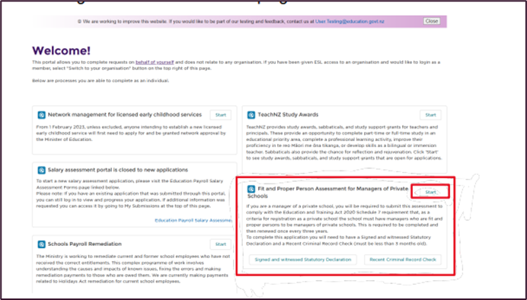
There will be a reminder at the top of the next screen about the documents needed for upload.
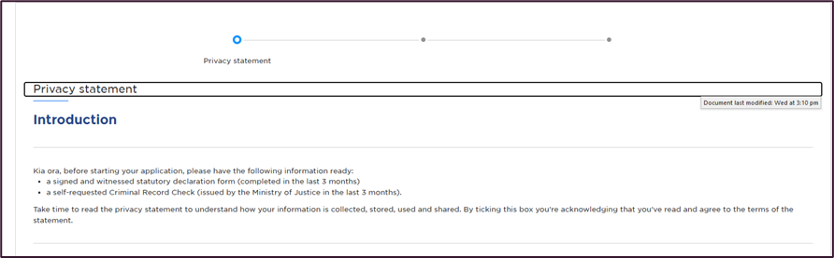

Step 5: Read and acknowledge the privacy statement
- Read the privacy statement and click the tick box to indicate that you have read it, and then click on the ‘next’ button in the bottom right.
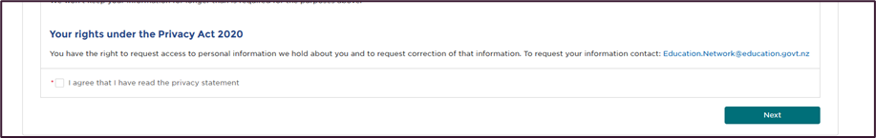

Step 6: Check your details
Your details should appear in the grey boxes at the top. These are the details you provided to your DA or to the ESL service desk when you requested access to an ESL user account.
If they are incorrect, please contact your DA or the Education Service Desk to amend them.

Step 7: Confirm whether you are a registered teacher and either enter your registration number or upload your criminal record check
If you are a registered teacher:
- Input your teacher registration number.
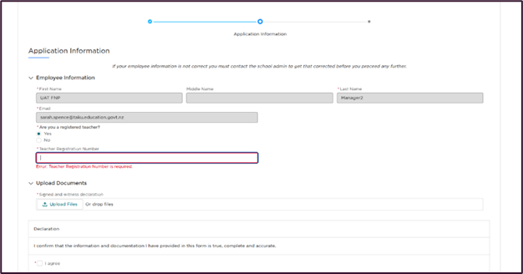

If you are not a registered teacher:
- Upload your Criminal Record Check. To do this, follow the instructions for uploading files in step 9 below.

Step 8: Upload your statutory declaration
- Choose the files you need one at a time and upload them.

- Choose the files you need one at a time and upload them.
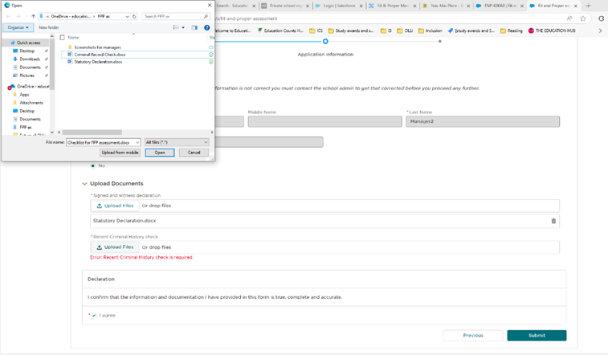

- Once you have uploaded the document, it will show that it has been uploaded, and you can click ‘done’. Please check that you have uploaded the correct document.
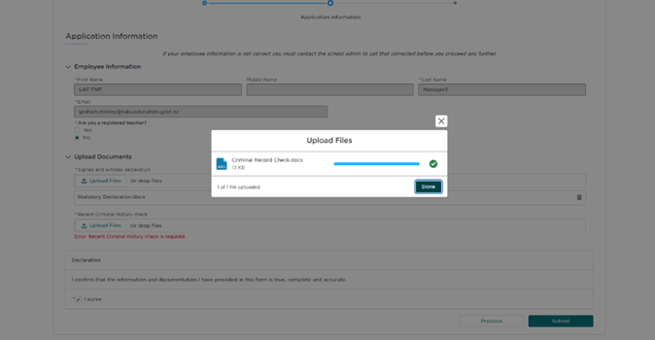

Step 9: Submit your application
- Once you have uploaded your documents, ensure that the information uploaded is true and correct and tick the declaration box.
- Click the ‘submit’ button at the bottom right of the form, and this will complete the application.
A confirmation screen will show that you are finished and provide you with your application number. You will also receive a confirmation email.
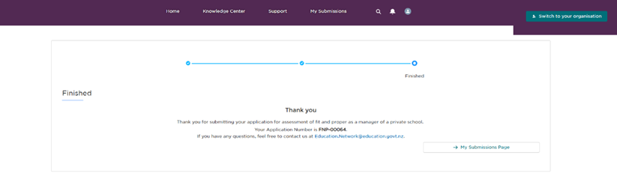
You don’t need to do anything else unless you receive an email from the assessor requesting more information. If this occurs, follow the instructions in Step 10: Providing more information if requested.

Where can I see my application once it has been submitted?
You can see it in the Fit and Proper app under the ‘My Submissions’ and then ‘My Fit and Proper Records’ - https://takueducationnz.my.site.com/s/.
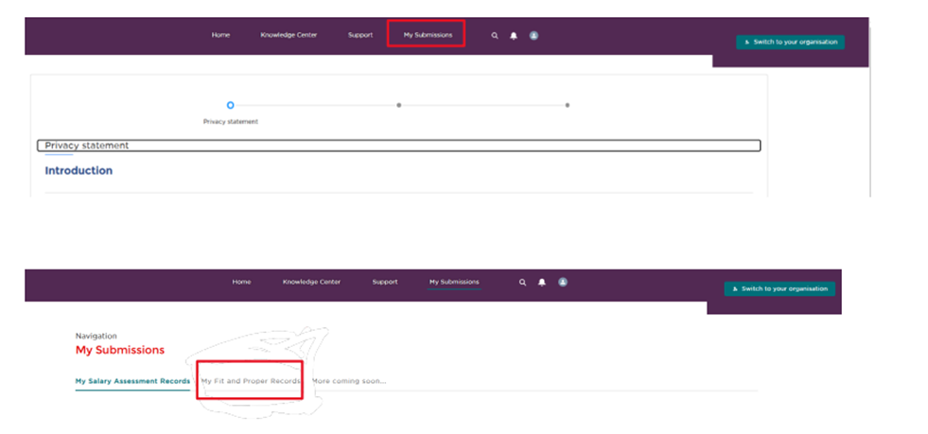

Application follow-up action

Step 10: Providing more information if requested
When an Senior Regulatory Advisors assessor is assessing your application, they may request that you provide additional information. If so, you will receive an email notifying you of this. Additional information is to be added to your current application. Do not submit a new application.
If you receive an email requesting more information, it will contain a link to a login page.
- Click the link, and it will take you to your active application.
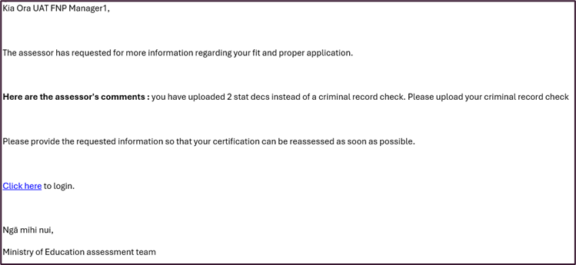

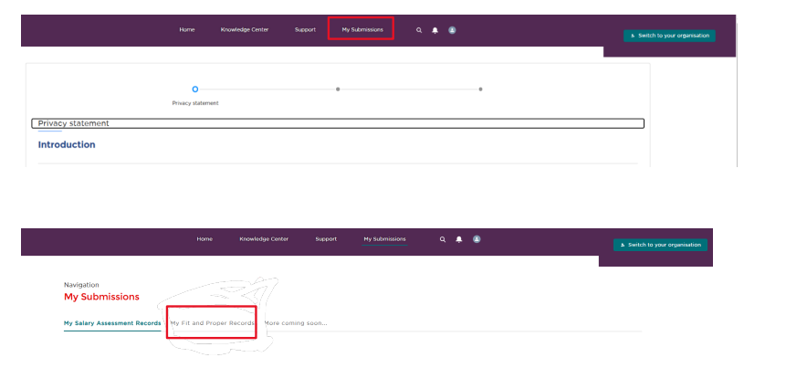
- Once logged in, you can find your application within ‘My submissions’ and ‘My fit and proper records.’

- In ‘My Fit and Proper Records’, you can find your application. In the ‘Assessor notes’ box, you will find details on what additional information you need to provide.
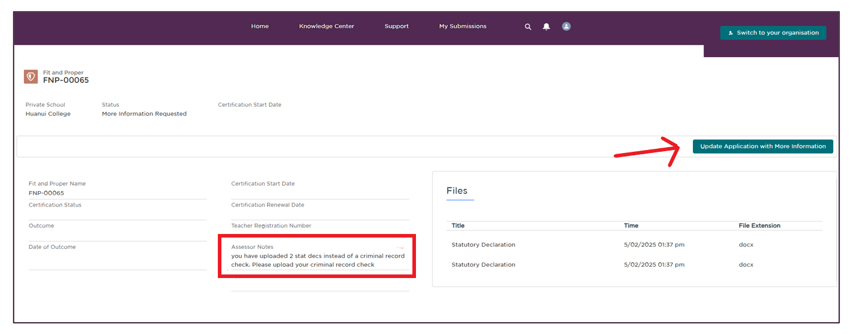
- Click on the ‘update application with more information’ button in the top right of the screen.

- Upload the additional information and submit.
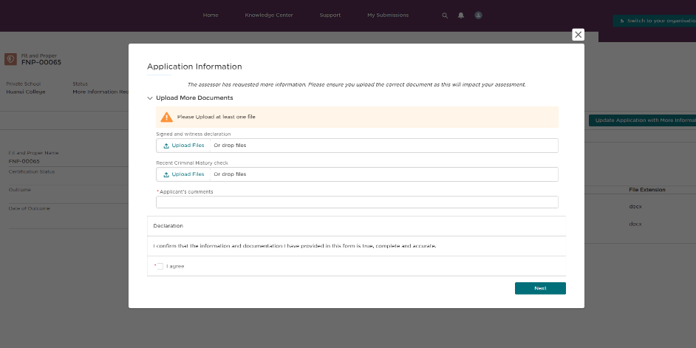

Once you submit the additional information needed, you will see a confirmation ‘Thank you’ message on the screen with the option to go back to your submissions.
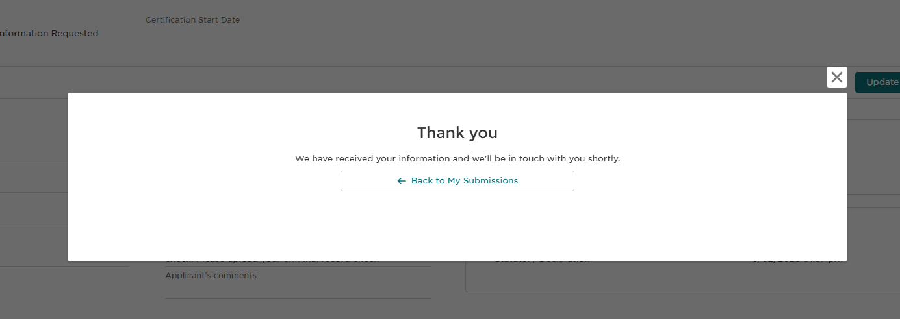

Application outcome – approved.

Application approved
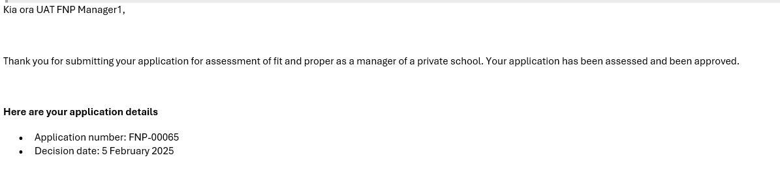
Once your application is assessed, you will receive an email informing you of the outcome and the date of the decision, as shown below. This usually takes 10 business days from when all necessary information has been submitted. No additional steps are required following this approval.

Application outcome – declined

Look at the rationale for the decline
If you are not assessed as fit and proper, you will be informed via email. To ascertain the rationale for the decline, follow the same steps set out in Step 10: Providing more information if requested, up to:
- ‘In ‘My Fit and Proper Records’ you can find your application.’
The ‘Assessors notes’ box will tell you why the application has been declined.

If you wish to, submit additional information in support of a reassessment
- If you wish to provide additional information in support of a reassessment of your application, let your RRH know (for information on who this is, refer back to here).
They will facilitate your application being reopened.
- You will then receive an email requesting that you submit additional information. Follow the instructions in Step 10: Providing more information if requested to provide additional information for application reassessment.
PRIVACY NOTE: Your ERO point of contact may not be the same person who assessed your application. If they aren’t, they will not have access to information relating to your application, including why your application was declined. Do not provide any additional information directly to them. You must submit this information in the reopened application, following the instructions in Step 10: Providing more information if requested.
After the additional information you have provided has been considered, you will receive an automated email letting you know whether your application has been approved or remains declined. If it is declined, you and the managers at your private school will be notified.
- If your application is declined after a reassessment, you must remove yourself as a manager of your private school.

